CONTENTS

- INTRODUCTION
  - OVERVIEW
2. ANALYSIS
2.1 SYSTEM ANALYSIS
2.2 SYSTEM SPECIFICATIONS

3. DESIGN APPROACH
3.1 INTRODUCTION TO DESIGN
3.2 UML DIAGRAMS
3.3 DATA FLOW DIAGRAMS
3.4 E-R DIAGRAMS

4. PROJECT MODULES

5. IMPLEMENTATION
4.1 CONCEPTS AND TECHNIQUES
4.2 TESTING
4.2.1 TEST CASES
6. OUTPUT SCREENS

7. CONCLUSION
8. FUTURE ENHANCEMENTS
9. BIBILIOGRAPHY

Introduction

1. INTRODUCTION
Library Management System consists of list of records about the management of the details of the students and the issues going on and also about some books and all. This is a web-based application. The project has two modules namely- User (Student), Librarian (Admin). According to the Modules the Distributor and Sub Distributors can manage and do their activities in easy manner. As the modern organizations are automated and computers are working as per the instructions, it becomes essential for the co-ordination of human beings, commodity and computers in a modern organization. The main purpose of this project is to maintain easy circulation system using computers and to provide different reports. The Library System is a package to be used by Libraries to improve the efficiency of Librarians, Library employees and users. The system provides books catalogue and information to members and helps them decide on the books to borrow from the library. The Librarian can keep the books catalogue updated all the time so that the members get the updated information all the time.

Online Library Management System (OLMS) is basically updating the manual library system into an internet-based application so that the users can know the details of their accounts, availability of books and remaining time for borrowing.

1.1 OVERVIEW
Library is place where all kind of books are available. Intranet Library Management system is a web based application. This system contains list of all the books and can be accessed by remote users concurrently from anywhere in the campus. But for that users must be registered user. This system is three tier architecture.
Admin sends requests, on receiving the request the server processes it and extracts the data from database and sends the result back to the users. This system provides separate interface and login for librarian and students. Librarian can modify database.
Users can search for books and renewal books online. They can recommend for new books by just sending messages to the librarian from anywhere in the university. They can view the issue and return dates of any book and due they have to pay. This system generates reports that can be used in analyzing the library performance. Thus the management can take appropriate steps to improve the facilities.

Analysis

2.1 SYSTEM ANALYSIS

A. Existing System
Various problems of physical system are described below: -
- If one is not very careful then there is a possibility of issuing more than one
book to a user.
- There is a possibility of issuing a book to a user, whose membership is not
there.
- When a user requests for a book, one has to physically check for the
presence of a book in the library
- Answering management query is a time consuming process.
- Daily keeping a manual record of changes taking place in the library such as
book being issued, book being returned etc. can become cumbersome if the
Library size is bigger.

B. Proposed System
The ONLINE LIBRARY MANAGEMENT SYSTEM is a software application which avoids more manual hours in taking the book, that need to spend in record keeping and generating reports. Maintaining of user details is complex in manual system in terms of agreements, royalty and activities. This all have to be maintained in ledgers or books. Co-coordinators need to verify each record for small information also.
- Easy search of book in the online library.
- Avoid the manual work.
- User need not go to the library for Issue any kind of book, he can renewal the book online.

C. Objective of the System
The goal of the system is to bring down the work load with the increased efficiency and to speed up the activities. With this it is very easy to process course fee that is collected time to time from students who are registered and studying at franchisees.

2.2 System Specifications

Hardware Requirements: -
- Hard disk : 1TB
- RAM : 4GB
- Processor : intel(R) core-i5-CPU

Software Requirements: -
- Operating System : Windows 95/98/XP with MS-office
- Programming language : Sublime Text
- Web-Technology : PHP (raw)
- Web Server : Xampp
- Database : MySQL

Architecture

3.1 INTRODUCTION
“Software architecture refers to the fundamental structures of a software system and the discipline of creating such structures and systems”

The structure comprises software elements, relations among them, and properties of both elements and relations. Software architecture is about making fundamental structural choices that are costly to change once implemented. Software architecture choices include specific structural options from possibilities in the design of the software.

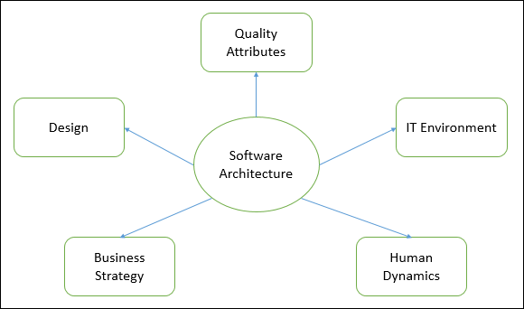

Architecture serves as a blueprint for a system. It provides an abstraction to manage the system complexity and establish a communication and coordination mechanism among components.
- It defines a structured solution to meet all the technical and operational requirements, while optimizing the common quality attributes like performance and security.
- Further, it involves a set of significant decisions about the organization related to software development and each of these decisions can have a considerable impact on quality, maintainability, performance, and the overall success of the final product.

3.2 Goals of Architecture
The primary goal of the architecture is to identify requirements that affect the structure of the application. A well-laid architecture reduces the business risks associated with building a technical solution and builds a bridge between business and technical requirements.
Some of the other goals are as follows −
- Expose the structure of the system, but hide its implementation details.
- Realize all the use-cases and scenarios.
- Try to address the requirements of various stakeholders.
- Handle both functional and quality requirements.
- Reduce the goal of ownership and improve the organization’s market position.
- Improve quality and functionality offered by the system.
- Improve external confidence in either the organization or system.

So as architectural theory, we firstly fixed the structure of OLMS and flow of execution through the components. Then applied quality attributes to the system functionality.

3.3 Limitations
- Lack of tools and standardized ways to represent architecture.
- Lack of analysis methods to predict whether architecture will result in an implementation that meets the requirements.
- Lack of awareness of the importance of architectural design to software development.
- Lack of understanding of the role of software architect and poor communication among stakeholders.
- Lack of understanding of the design process, design experience and evaluation of design.

3.4 Role of Software Architect
A Software Architect provides a solution that the technical team can create and design for the entire application. So architect need to be –

- Design expertise
- Domain expertise
- Technology expertise

3.5 Quality Attributes
Quality attribute is property of a work product by which its quality will be judged by stakeholders. It is a measure of excellence or the state of being free from deficiencies or defects. Quality attribute requirements are part of an application’s nonfunctional requirements, which capture the many facets of how the functional requirements of an application are achieved.

Category | Quality Attribute | Description | OLMS
Design Qualities | Conceptual Integrity | Defines the consistency and co-herence of the overall design. This includes the way components or modules are designed. | Design of profile, book-list, approve - request, manage student, register module etc.
Design Qualities | Maintainability | Ability of the system to undergo changes with a degree of ease. | Keep the flow of the system and each module activity.
Design Qualities | Reusability | Defines the capability for components and subsystems to be suitable for use in other applications. | The modules of OLMS will be decoupled for re-usability.
Run-time Qualities | Interoperability | Ability of a system or different systems to operate successfully by communicating and exchanging information with other external systems written and run by external parties. | Third party modules or system should com-municate and exchange information easily with-out any complexity.
Run-time Qualities | Manageability | Defines how easy it is for system administrators to manage the application. | It should not be a com-plex system that libra-rians or students need more technical know-ledge.
Run-time Qualities | Reliability | Ability of a system to remain operational over time. | Librarians or students operation should not terminate inconsistently.
Run-time Qualities | Scalability | Ability of a system to either handle the load increase without impacting the performance of the system or the ability to be readily enlarged. | System should manage many request simul-taneously without in-crease waiting time.
Run-time Qualities | Security | Capability of a system to prevent malicious or accidental actions outside of the designed usages. | SQLi, XSS, database hack or any other attack issue have to consider.
Run-time Qualities | Performance | Indication of the responsiveness of a system to execute any action within a given time interval. | Load time or request / approval should be smooth.
Run-time Qualities | Availability | Defines the proportion of time that the system is functional and working. It can be measured as a percentage of the total system downtime over a predefined period. | The system should be available 24 hours to authenticated users and admin.
System Qualities | Supportability | Ability of the system to provide information helpful for identifying and resolving issues when it fails to work correctly. | System should informed exact reason for any inconsistent situation.
System Qualities | Testability | Measure of how easy it is to create test criteria for the system and its components. | Each components need to be testable for gets a bug free system.
User Qualities | Usability | Defines how well the application meets the requirements of the user and consumer by being intuitive. | Students and librarians should be happy and get relatable actions.
Architecture Quality | Correctness | Accountability for satisfying all the requirements of the system. | System should correctly render.
Non-runtime Quality | Portability | Ability of the system to run under different computing environment. | OLMS should be run on desktop and also in mobile devices
Non-runtime Quality | Integrality | Ability to make separately developed components of the system work correctly together. | Modules/components should not conflict each other.
Non-runtime Quality | Modifiability | Ease with which each software system can accommodate changes to its software. | System will be modifi-able for future extension and new features.
Business quality attributes | Cost and schedule | Cost of the system with respect to time to market, expected project lifetime & utilization of legacy. | Cost will depends on modules and complexity of these.
Business quality attributes | Marketability | Use of system with respect to market competition. | The system may publish for business demand.

Design

4.1 INTRODUCTION
“Software design is a process to transform user requirements into some suitable form, which helps the programmer in software coding and implementation”

Design is the first step in the development phase for any techniques and principles for the purpose of defining a device, a process or system in sufficient detail to permit its physical realization. Once the software requirements have been analyzed and specified (SRS) the software design is started.

Software design is the third step in SDLC (Software Development Life Cycle), which moves the concentration from problem domain to solution domain. It tries to specify how to fulfill the requirements mentioned in SRS. The design activities are of main importance in this phase, because in this activity, decisions ultimately affecting the success of the software implementation and its ease of maintenance are made. These decisions have the final bearing upon reliability and maintainability of the system. Design is the only way to accurately translate the customer’s requirements into finished software or a system.

4.2 Software Design Levels
Software design yields three levels of results.
- Architectural Design - The architectural design is the highest abstract version of the system. It identifies the software as a system with many components interacting with each other. At this level, designers get the idea of proposed solution domain.
The all constraints in conventional library management sytem is get solved by this design proposal. It defined priviledges of student (user) and admin (librarian) and how the OLMS will established.
*Online Library Management System (OLMS)
- High-level Design- The high-level design breaks the ‘single entity-multiple component’ concept of architectural design into less-abstracted view of sub-systems and modules and depicts their interaction with each other. High-level design focuses on how the system along with all of its components can be implemented in forms of modules. It recognizes modular structure of each sub-system and their relation and interaction among each other.
User and admin registration, authorization, verification, dashbord, book lists, book request, approving etc all the components depicted in HLD (High Level Design).
- Detailed Design- Detailed design deals with the implementation part of what is seen as a system and its sub-systems in the previous two designs. It is more detailed towards modules and their implementations. It defines logical structure of each module and their interfaces to communicate with other modules. This design also known as Low Level Design (LLD).
It’s the last design level where system is decorated logically and programmers get a well purnished document for implement the sytem. This design reached our system to fourth SDLC phase development (coding).

4.3 Modularization
Modularization is a technique to divide a software system into multiple discrete and independent modules, which are expected to be capable of carrying out task(s) independently. These modules may work as basic constructs for the entire software. Designers tend to design modules such that they can be executed and/or compiled separately and independently.
Modular design unintentionally follows the rules of ‘divide and conquer’ problem-solving strategy this is because there are many other benefits attached with the modular design of a software.
Advantage of modularization:
- Smaller components are easier to maintain
- Program can be divided based on functional aspects
- Desired level of abstraction can be brought in the program
- Components with high cohesion can be re-used again
- Concurrent execution can be made possible
- Desired from security aspect
For the OLMS we modularized the whole system in small parts. These are – registration module, login module, dashboard module, book request – approve module, mailer module, fine and other functional module.

4.4 Coupling and Cohesion
When a software program is modularized, its tasks are divided into several modules based on some characteristics. As we know, modules are set of instructions put together in order to achieve some tasks. They are though, considered as single entity but may refer to each other to work together. There are measures by which the quality of a design of modules and their interaction among them can be measured. These measures are called coupling and cohesion.

4.4.1 Cohesion
Cohesion is a measure that defines the degree of intra-dependability within elements of a module. The greater the cohesion, the better is the program design.
There are seven types of cohesion, namely –
- Co-incidental cohesion - It is unplanned and random cohesion, which might be the result of breaking the program into smaller modules for the sake of modularization. Because it is unplanned, it may serve confusion to the programmers and is generally not-accepted.
- Logical cohesion - When logically categorized elements are put together into a module, it is called logical cohesion.
- Temporal Cohesion - When elements of module are organized such that they are processed at a similar point in time, it is called temporal cohesion.
- Procedural cohesion - When elements of module are grouped together, which are executed sequentially in order to perform a task, it is called procedural cohesion.
- Communicational cohesion - When elements of module are grouped together, which are executed sequentially and work on same data (information), it is called communicational cohesion.
- Sequential cohesion - When elements of module are grouped because the output of one element serves as input to another and so on, it is called sequential cohesion.
- Functional cohesion - It is considered to be the highest degree of cohesion, and it is highly expected. Elements of module in functional cohesion are grouped because they all contribute to a single well-defined function. It can also be reused.

So we are aimed to achive all types of cohesion for high quality system of online library management.

4.4.2 Coupling
Coupling is a measure that defines the level of inter-dependability among modules of a program. It tells at what level the modules interfere and interact with each other. The lower the coupling, the better the program.
There are five levels of coupling, namely -
- Content coupling - When a module can directly access or modify or refer to the content of another module, it is called content level coupling.
- Common coupling- When multiple modules have read and write access to some global data, it is called common or global coupling.
- Control coupling- Two modules are called control-coupled if one of them decides the function of the other module or changes its flow of execution.
- Stamp coupling- When multiple modules share common data structure and work on different part of it, it is called stamp coupling.
- Data coupling- Data coupling is when two modules interact with each other by means of passing data (as parameter). If a module passes data structure as parameter, then the receiving module should use all its components.
Ideally, no coupling is considered to be the best. So we have to careful sothat there have minimum coupled modules in our OLMS.

4.5 UML DIAGRAMS
UML stands for Unified Modeling Language. UML is a language for specifying, visualizing and documenting the system. This is the step while developing any product after analysis. The goal from this is to produce a model of the entities involved in the project which later need to be built. The representation of the entities that are to be used in the product being developed need to be designed. There are various kinds of methods in software design. They are as follows:
- Use case Diagram
- Sequence Diagram
- Activity Diagram

4.5.1 USECASE DIAGRAMS
Use case diagrams model behavior within a system and helps the developers understand of what the user require. The stick man represents what’s called an actor. Use case diagram can be useful for getting an overall view of the system and clarifying who can do and more importantly what they can’t do.

Use case diagram consists of use cases and actors and shows the interaction between the use case and actors.
- The purpose is to show the interactions between the use case and actor.
- To represent the system requirements from user’s perspective.
- An actor could be the end-user of the system or an external system.

A Use case is a description of set of sequence of actions. Graphically it is rendered as an ellipse with solid line including only its name. Use case diagram is a behavioral diagram that shows a set of use cases and actors and their relationship.

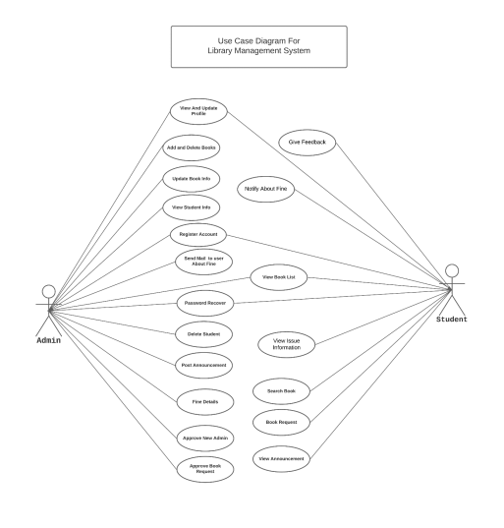

.

4.5.2 SEQUENCE DIAGRAM
Sequence diagram and collaboration diagram are called interaction diagrams. An interaction diagram shows an interaction, consisting of set of objects and their relationship including the messages that may be dispatched among them.

A sequence diagram is an introduction that empathizes the time ordering of messages. Graphically a sequence diagram is a table that shows objects arranged along the X-axis and messages ordered in increasing time along the Y-axis

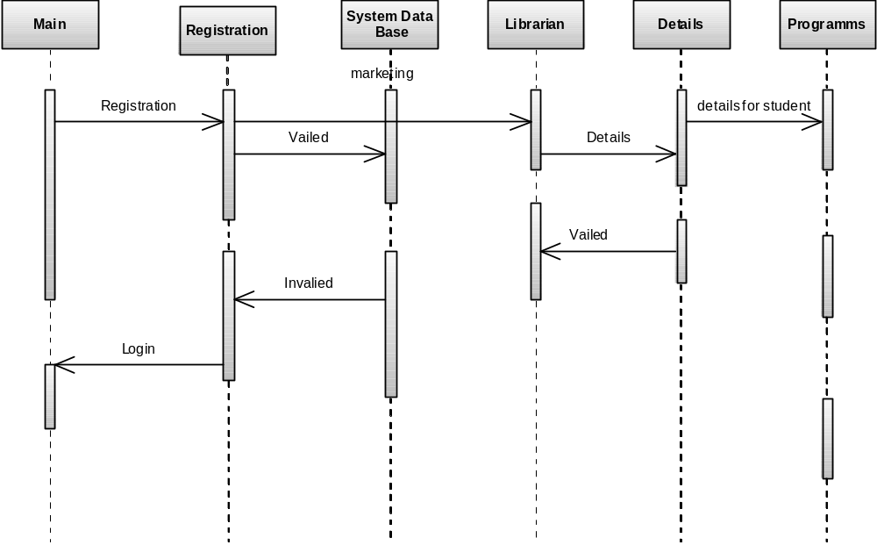
4.5.3 ACTIVITY DIAGRAM
Activity diagram is essentially an advanced version of flow chart that modeling the flow from one activity to another activity.

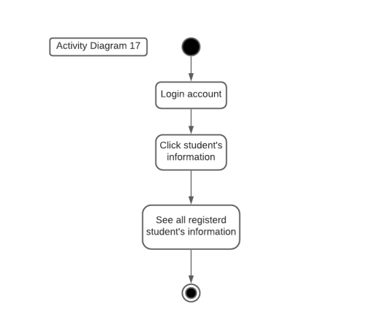

4.6
DATA FLOW DIAGRAMS (DFD)
The DFD takes an input-process-output view of a system i.e. data objects flow into the software, are transformed by processing elements, and resultant data objects flow out of the software. Data objects represented by labeled arrows and transformation are represented by circles also called as bubbles.

A context-level DFD for the system the primary external entities produce information for use by the system and consume information generated by the system. The labeled arrow represents data objects or object hierarchy.

4.7 E-R Diagrams
The Entity-Relationship (ER) model is a conceptual data model that views the real world as entities and relationships. A basic component of the model is the Entity-Relationship diagram which is used to visually represents data objects.
- It maps well to the relational model. The constructs used in the ER model can easily be transformed into relational tables.
- It is simple and easy to understand with a minimum of training. Therefore, the model can be used by the database designer to communicate the design to the end user.
- In addition, the model can be used as a design plan by the database developer to implement a data model in a specific database management software.

4.7.1 Connectivity and Cardinality
The basic types of connectivity for relations are: one-to-one, one-to-many, and many-to-many. A one-to-one (1:1) relationship is when at most one instance of a entity A is associated with one instance of entity B. For example, "employees in the company are each assigned their own office. For each employee there exists a unique office and for each office there exists a unique employee.
A one-to-many (1:N) relationships is when for one instance of entity A, there are zero, one, or many instances of entity B, but for one instance of entity B, there is only one instance of entity A. An example of a 1:N relationships is a department has many employees each employee is assigned to one department.
A many-to-many (M:N) relationship, sometimes called non-specific, is when for one instance of entity A, there are zero, one, or many instances of entity B and for one instance of entity B there are zero, one, or many instances of entity A. The connectivity of a relationship describes the mapping of associated

4.7.2 ER Notation
All notational styles represent entities as rectangular boxes and relationships as lines connecting boxes. Each style uses a special set of symbols to represent the cardinality of a connection. The notation used in this document is from Martin. The symbols used for the basic ER constructs are:
- Entities are represented by labeled rectangles. The label is the name of the entity. Entity names should be singular nouns.
- Relationships are represented by a solid line connecting two entities. The name of the relationship is written above the line. Relationship names should be verbs
- Attributes, when included, are listed inside the entity rectangle. Attributes which are identifiers are underlined. Attribute names should be singular nouns.
- Cardinality of many is represented by a line ending in a crow's foot. If the crow's foot is omitted, the cardinality is one.
- Existence is represented by placing a circle or a perpendicular bar on the line. Mandatory existence is shown by the bar (looks like a 1) next to the entity for an instance is required. Optional existence is shown by placing a circle next to the entity that is optional

*OLMS E-R diagram shown the next page.

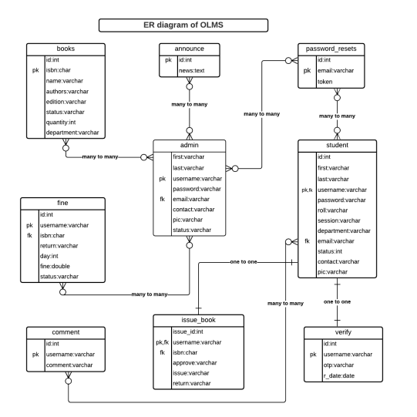

MODULES

5. MODULES
The proposed system categories and follows these modules to implement.

Login component
- Librarian (ADMIN)
- Students (USER)

Librarian Component
- Librarian Dashboard

Student Component
- Books Details
- Issue Details

5.1 MODULES DESCRIPSTION
User: Using login id and password user can the use Library online where users can search for books and renewal books online. They can recommend for new books by just sending messages to the librarian from anywhere in the college. They can view the issue and return dates of any book and due they have to pay.

Registration: In the Registration module, user has to register himself by supplying his personal information which gets store in data base which are using as backend. By registering himself user will get his login id and Password so that he can access Library online. Separate Register form should be designed for separate user
(Student, Faculty, Librarian) and separate login has to provide for each user. For example, if the users are students then student id should be ASH/BKH********M/F.

Librarian: Librarian is a person who manages the Library. Librarian has the permission that he can access the database. There are some tasks which are performed by the Librarian like:
- Addition of a new book.
- Modification of the book.
- Deletion of the book.
- Searching of the book.
- Managing User

5.3 BACK END TECHNOLOGY

Microsoft SQL Server
Microsoft SQL Server is a Structured Query Language (SQL) based, client/server relational database. Each of these terms describes a fundamental part of the architecture of SQL Server.

Database
A database is similar to a data file in that it is a storage place for data. Like a data file, a database does not present information directly to a user; the user runs an application that accesses data from the database and presents it to the user in an understandable format. A database typically has two components: the files holding the physical database and the database management system (DBMS) software that applications use to access data. The DBMS is responsible for enforcing the database structure, including:

- Maintaining the relationships between data in the database.
- Ensuring that data is stored correctly and that the rules defining data relationships
are not violated.
- Recovering all data to a point of known consistency in case of system failures.

Relational Database
There are different ways to organize data in a database but relational databases are one of the most effective. Relational database systems are an application of mathematical set theory to the problem of effectively organizing data. In a relational database, data is collected into tables (called relations in relational theory). When organizing data into tables, we can usually find many different ways to define tables. Relational database theory defines a process, normalization, which ensures that the set of tables you define will organize your data effectively.
We used relational database in our Online Library Management System.

Client/Server:-
In a client/server system, the server is a relatively large computer in a central location that manages a resource used by many people. When individuals need to use the resource, they connect over the network from their computers, or clients, to the server.

Server applications are usually capable of working with several clients at the same time. As OLMS system will handle so many students at a time so we need establish client – server system. That will be infrangible and reliable.
.

Structured Query Language (SQL):-
To work with data in a database, we must use a set of commands and statements (language) defined by the DBMS software. There are several different languages that can be used with relational databases; the most common is SQL.

We will implement sql to interact with our relational database. It is convenient and easy for developers.

5.4 DATABASE MODELS
There are single tier, two tier and multi-tier database model. We can use single or two tier model in our Online Library Management System.

Single Tier / 1-Tier
In a single tier the server and client are the same in the sense that a client program that needs information (client) and the source of this type of architecture is also possible in java, in case flat files are used to store the data. However this is useful only in case of small applications. The advantage with this is the simplicity and portability of the application developed.

Server & client

Database

Two Tier (client-server)
In two tier architecture the database resides in one machine and client in different machine they are connected through the network. In this type of architecture a database management takes control of the database and provides access to clients in a network. This software bundle is also called as the server. Software in different machines, requesting for information are called as the clients.

Server

Client

Client

Database

Any of the two models we can implement in our OLMS.

5.5 INTERNET AND INTRANET
Internet is network of computers. It is not just a network, but a network of networks. Internet is global communication system of diverse, inter-connected computer network for the exchange of information of virtually every remote area.

Intranet is a local or restricted communications network, especially a private network created for any specific organization for their secrecy. It is bounded network through the target organization.

If we want to use Online Library Management System for a university then we can set up intranet network and if we want world wide access then it need to set up in internet.

5.6 DATABASE TABLES

Table: insertbook
BOOKID | INT,
TITLE | VARCHAR(150),
AUTHOR | VARCHAR(100),
YEARPUBLISHED | VARCHAR(20),
CATEGORY | VARCHAR(100),
PUBLISHER | VARCHAR(100),
EDITION | VARCHAR(50),
COST | VARCHAR(20),
DATEOFENTRY | DATETIME,
LIBRARYCOPY | INT,
STATUS | VARCHAR(20),
CONDITION | VARCHAR(20)

Table: librarybooks
BOOKID | INT NULL,
TITLE | VARCHAR(150) NULL,
AUTHOR | VARCHAR(100) NULL,
YEARPUBLISHED | VARCHAR(20) NULL,
CATEGORY | VARCHAR(100) NULL,
PUBLISHER | VARCHAR(100) NULL,
EDITION | VARCHAR(50) NULL,
COST | VARCHAR(20) NULL,
DATEOFENTRY | DATETIME NULL,
LIBRARYCOPY | INT NULL,
STATUS | VARCHAR(20) NULL,
CONDITION | VARCHAR(20) NULL

Table: issuebook
TRNSID | INT NULL,
ROLLNUMBER | INT NULL,
NAME | VARCHAR(150) NULL,
AGE | INT NULL,
GENDER | VARCHAR(10) NULL,
BRANCH | VARCHAR(10) NULL,
YEAR | INT NULL,
BARTYPE | VARCHAR(15) NULL,
BOOKID | INT NULL,
TITLE | VARCHAR(150) NULL,
AUTHOR | VARCHAR(150) NULL,
CATEGORY | VARCHAR(100) NULL,
EDITION | VARCHAR(20) NULL,
PUBLISHER | VARCHAR(50) NULL,
LIBRARYCOPY | INT NULL,
ISSUEDATE | DATETIME NULL,
DUEBACKBY | DATETIME NULL

5.7 FEASIBILITY STUDY
Feasibility study is conducted once the problem is clearly understood. Feasibility study is a high level capsule version of the entire system analysis and design process. The objective is to determine quickly at a minimum expense how to solve a problem. The purpose of feasibility is not to solve the problem but to determine if the problem is worth solving.

The system has been tested for feasibility in the following points.
1. Technical Feasibility
2. Economical Feasibility
3. Operational Feasibility.

1. Technical Feasibility
The project entitles "Courier Service System” is technically feasibility because of the below mentioned feature. The project was developed in Java which Graphical User Interface.
It provides the high level of reliability, availability and compatibility. All these make Java an appropriate language for this project. Thus the existing software Java is a powerful language.

2. Economical Feasibility
The computerized system will help in automate the selection leading the profits and details of the organization. With this software, the machine and manpower utilization are expected to go up by 80-90% approximately. The costs incurred of not creating the system are set to be great, because precious time can be wanted by manually.

3. Operational Feasibility
In this project, the management will know the details of each project where he may be presented and the data will be maintained as decentralized and if any inquires for that particular contract can be known as per their requirements and necessaries.

Maintenance and environment:

AS the number of computer based systems, grieve libraries of computer software began to expand. In house developed projects produced tones of thousand soft program source statements. Software products purchased from the outside added hundreds of thousands of new statements. A dark cloud appeared on the horizon. All of these programs, all of those source statements-had to be corrected when false were detected, modified as user requirements changed, or adapted to new hardware that was purchased. These activities were collectively called software Maintenance.
The maintenance phase focuses on change that is associated with error correction, adaptations required as the software's environment evolves, and changes due to enhancements brought about by changing customer requirements. Four types of changes are encountered during the maintenance phase.

Correction
Adaptation
Enhancement
Prevention

Correction:

Even with the best quality assurance activities is lightly that the customer will uncover defects in the software. Corrective maintenance changes the software to correct defects.

Maintenance is a set of software Engineering activities that occur after software has been delivered to the customer and put into operation. Software configuration management is a set of tracking and control activities that began when a software project begins and terminates only when the software is taken out of the operation.

We may define maintenance by describing four activities that are undertaken after a program is released for use:
Corrective Maintenance
Adaptive Maintenance
Perfective Maintenance or Enhancement
Preventive Maintenance or reengineering

Only about 20 percent of all maintenance work are spent "fixing mistakes". The remaining 80 percent are spent adapting existing systems to changes in their external environment, making enhancements requested by users, and reengineering an application for use.

ADAPTATION:

Over time, the original environment (E>G., CPU, operating system, business rules, external product characteristics) for which the software was developed is likely to change. Adaptive maintenance results in modification to the software to accommodate change to its external environment.

ENHANCEMENT:

As software is used, the customer/user will recognize additional functions that will provide benefit. Perceptive maintenance extends the software beyond its original function requirements.

PREVENTION:

Computer software deteriorates due to change, and because of this, preventive maintenance, often called software re engineering, must be conducted to enable the software to serve the needs of its end users. In essence, preventive maintenance makes changes to computer programs so that they can be more easily corrected, adapted, and enhanced. Software configuration management (SCM) is an umbrella activity that is applied throughout the software process. SCM activities are developed to

SOFTWARE METHODOLOGY

The software methodology followed in this project includes the object-oriented methodology and the application system development methodologies. The description of these methodologies is given below.

Application System Development – A Life cycle Approach

Although there are a growing number of applications (such as decision support systems) that should be developed using an experimental process strategy such as prototyping, a significant amount of new development work continue to involve major operational applications of broad scope. The application systems are large highly structured. User task comprehension and developer task proficiency is usually high. These factors suggest a linear or iterative assurance strategy. The most common method for this stage class of problems is a system development life cycle modal in which each stage of development is well defined and has straightforward requirements for deliverables, feedback and sign off. The system development life cycle is described in detail since it continues to be an appropriate methodology for a significant part of new development work.

The basic idea of the system development life cycle is that there is a well-defined process by which an application is conceived and developed and implemented. The life cycle gives structure to a creative process. In order to manage and control the development effort, it is necessary to know what should have been done, what has been done, and what has yet to be accomplished. The phrases in the system development life cycle provide a basis for management and control because they define segments of the
flow of work, which can be identified for managerial purposes and specifies the documents or other deliverables to be produced in each phase.

The phases in the life cycle for information system development are described differently by different writers, but the differences are primarily in the amount of necessity and manner of categorization. There is a general agreement on the flow of development steps and the necessity for control procedures at each stage.

The information system development cycle for an application consists of three major stages.

- Definition.
- Development.
- Installation and operation.

The first stage of the process, which defines the information requirements for a feasible cost effective system. The requirements are then translated into a physical system of forms, procedures, programs etc., by the system design, computer programming and procedure development. The resulting system is test and put into operation. No system is perfect so there is always a need for maintenance changes. To complete the cycle, there should be a post audit of the system to evaluate how well it performs and how well it meets the cost and performance specifications. The stages of definition, development and installation and operation can therefore be divided into smaller steps or phrases as follows.

Definition

Proposed definition : preparation of request for proposed applications.
Feasibility assessment : evaluation of feasibility and cost benefit of proposed system.
Information requirement analysis : determination of information needed.

Design
Conceptual design : User-oriented design of application development.
Physical system design : Detailed design of flows and processes in applications processing system and preparation of program specification.
Development
Program development : coding and testing of computer programs.
Procedure development : design of procedures and preparation of user instructions.

Installation and operation

Conversion : final system test and conversion.
Operation and maintenance : Month to month operation and maintenance
Post audit : Evaluation of development process,application system and results of use at the completion of the each phase, formal approval sign-off is required from the users as well as from the manager of the project development.

6. CONCLUSION

The package was designed in such a way that future modifications can be done easily. The following conclusions can be deduced from the development of the project.

  - Library Management System of the entire system improves the efficiency.
  - It provides a friendly graphical user interface which proves to be better when compared to the existing system.
  - It gives appropriate access to the authorized users depending on their permissions.
  - It effectively overcomes the delay in communications.
  - Updating of information becomes so easier.
  - System security, data security and reliability are the striking features.
  - The System has adequate scope for modification in future if it is necessary.



7. FUTURE ENHANCEMENTS:

This application avoids the manual work and the problems concern with it. It is an easy way to obtain the information regarding the various products information that are present in the Library of a particular college.
Well I and my team members have worked hard in order to present an improved website better than the existing one’s regarding the information about the various activities. Still we found out that the project can be done in a better way. Primarily, when we request information about a particular product it just shows the company, product id, product name and no. of quantities available. So, after getting the information we can get access to the product company website just by a click on the product name.
The next enhancement that we can add the searching option. We can directly search to the particular product company from this site .These are the two enhancements that we could think of at present.

